Detectable Warning Surfaces

What are detectable warnings?
Detectable warnings are “A standardized surface feature built in or applied to walking surfaces or other elements to warn of hazards on a circulation path.” (F106.5, Department of Justice 2010 ADA Standards) They are a unique and standardized feature, intended to function much like a stop line alerting pedestrians who are visually impaired to the presence of a hazard in their line of travel. Detectable warnings are also sometimes called truncated domes or truncated dome detectable warning surfaces.

Why are they necessary?
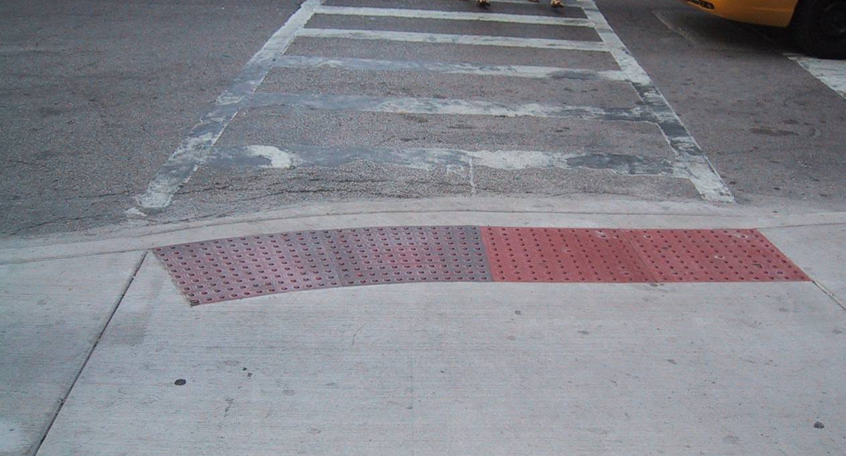
Curb ramps have become common in response to the requirements of the Rehabilitation Act (1973) and the Americans with Disabilities Act (1990). An unintended consequence of that has been that blind pedestrians have found it more difficult to locate the boundary between the street and sidewalk. The only surface repeatedly demonstrated to be detectable to most blind pedestrians, either under foot or by the use of a long cane, is the truncated dome detectable warning surface.
Figure 1: Photo of detectable warnings installed full width of curb ramp, 2 feet in direction of travel

Specifications
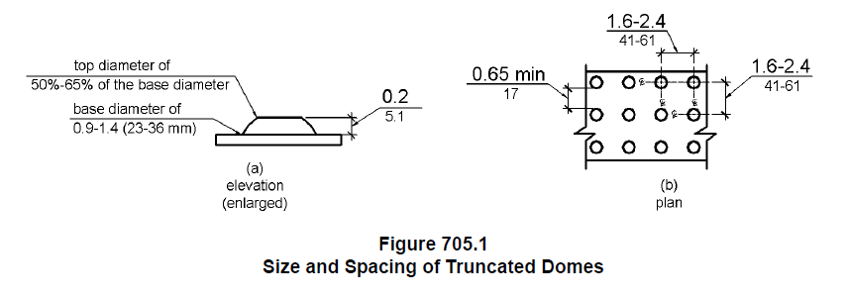Both the Proposed Accessibility Guidelines for Pedestrian Facilities in the Public Right-of-Way, published 7/26/2011, (Proposed PROWAG) and the ADA Standards provide specifications for the surface that is recognized as a detectable warning surface. Surfaces made up of grids or lines are not “detectable warning surfaces”. The language in the standards requires a dome size within a certain range, consistent spacing of the domes, that the domes be aligned in a square grid pattern, and that the detectable warning surfaces contrast visually with adjoining surfaces, either light-on-dark or dark-on-light. The graphic above shows the specifications for the dome height and alignment.

Installation
There is a great deal of confusion regarding the requirements for installation of detectable warning surfaces. Detectable warnings have been required on transit platform edges since 1991 and at curb ramps and blended transitions in the public right-of-way since July 2001. However, the requirement for detectable warning surfaces on curb ramps and blended transitions from building driveways or parking lots to sidewalks has been dropped from the 2010 ADA Standards for Title III facilities (commercial buildings and facilities open to the public). Even though the Proposed PROWAG has not been finalized, the Federal Highway Administration has issued a memorandum recommending the use of the draft PROWAG as best practice in the public right-of-way (January 23, 2006; http://www.fhwa.dot.gov/environment/bikeped/prwaa.htm). In November 2006, DOT adopted the 2004 revisions to ADAAG (which did not include detectable warnings on curb ramps) and added requirements for detectable warnings on curb ramps in transportation facilities (http://edocket.access.gpo.gov/2006/pdf/E6-16680.pdf).

Proposed PROWAG requires detectable warnings where the sidewalk intersects the street to alert individuals who are blind that they are about to step into the vehicular facility, specifically at:
- “Curb ramps and blended transitions at pedestrian street crossings;
- Pedestrian refuge islands;
- Pedestrian at-grade rail crossings not located within a street or highway;
- Boarding platforms at transit stops for buses and rail vehicles where the edges of the boarding platform are not protected by screens or guards; and
- Boarding and alighting areas at sidewalk or street level transit stops for rail vehicles where the side of the boarding and alighting areas facing the rail vehicles is not protected by screens or guards.”

An advisory note clarifies that the detectable warning surfaces are not intended to provide wayfinding information for pedestrians who are blind or have low vision, just to indicate the boundary between pedestrian and vehicular routes where there is a flush rather than a curbed connection.

Specifications for placement require the detectable warnings to be two feet in the direction of travel and the full width of a curb ramp or level transition to the street.

Proposed PROWAG and additional materials on contrast, durability and maintenance of detectable warnings are available on the Access Board site at www.access-board.gov, under the heading, Street and Sidewalks, then Public Rights-of-Way. There are a number of truncated dome products available for installation on curb ramps in various climates and conditions.

